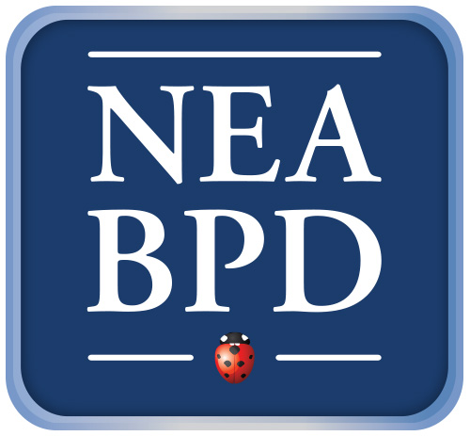

Family Education Workshops -2016-2017 Schedule
Thursdays 5:00 pm - 6:00 pm PIERCE HALL, Service Building
FREE and OPEN to the PUBLIC
___________________________________________________________________

December 15, 2016

“Good Psychiatric Management: GPM”
John Gunderson, M.D. (Professor of Psychiatry, Harvard Medical School, Senior Teaching and Clinical Supervisor, Borderline Personality Disorder Center and Training Institute, McLean Hospital)

January 19, 2017

“Suicide in BPD”
Igor Weinberg, PhD,( Associate Psychologist, Adult Outpatient Services, Gunderson Outpatient Program, McLean Hospital)

February 16, 2017
Claire Brickell, M.D., (Gunderson Residence psychiatrist, McLean Hospital)

March 16, 2017

“Validation”
Elizabeth Murphy, PhD, (Associate Psychologist, Adult Outpatient Services, Gunderson Outpatient Program, McLean Hospital)

April 20, 2017
“DBT- Dialectical Behavioral Therapy”
Joan Wheelis, M.D.,( Director of DBT Training Clinic, McLean Hospital, Director of Two Brattle Center)

May 18, 2017
Patient Panel
George Smith, LICSW, (Clinical Director Gunderson Outpatient Program, Adult Outpatient Clinic Group Director, McLean Hospital)

