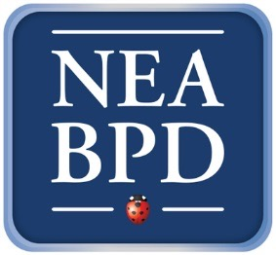
Family Connections Leaders’ Training December 9, 10, 11, 2016 Belmont, Mass

Family Connections (FC) is a free, 12-session group education, individual/family skill and social support program for parents and partners (and other loved ones) of people with BPD. Several published studies support its effectiveness, and FC is now available in at least 19 countries and also via teleconference. Groups are co-led by two trained family members and/or professionals.

NEA-BPD is proud to announce the next Family Connections leader training.
Led by Dr. Alan Fruzzetti (with help from Family Connections leaders, both therapists and family members), this training is co-hosted by The McLean Borderline Personality Disorder Training Institute and training costs will therefore be covered. Participants are only responsible for the cost of the Friday night dinner, their own travel expenses and lodging.

The training weekend will begin with dinner together on Friday night (Dec 9) and continue all day on Saturday and Sunday (Dec 10 and 11).

Both professionals and family members are welcome to attend this leader training. Family members who come for the FC Leader Training must already have participated either in an FC group or in a DBT family psychoeducation or other family program (NAMI). Professionals committed to offering Family Connections groups (without fees to participants) are welcome.

NEABPD will pair new leaders with experienced family members or professionals to run groups; so participants can attend alone, or come with someone who will be their FC partner.

For more information about the National Education Alliance for Borderline Personality Disorder (the non-profit/all volunteer organization that sponsors Family Connections), go to:
www.borderlinepersonalitydisorder.com

If you are a family member, please send an email to NEABPDtraining@gmail.com and answer:
1. Name, address, email and phone
2. What FC class you completed: In-person or on the phone. Year of attendance
3. Who were your co-leaders
4. Age and relationship of your loved one with BPD
5. Brief paragraph why you want to be a leader and if you have someone who is interested in being a co-leader with you.

If you are a professional, please send an email to NEABPDtraining@gmail.com and answer:
- Name, credentials, address, email and phone
- Why you want to run a Family Connections group
- Where you might run the group
- Commitment to offer the course for free

