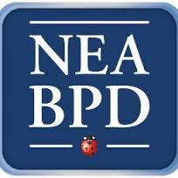
Family Education Workshops -2015-2016 Schedule
Thursdays 6:00 pm-7:15 pm DeMarneffe Building, Room 132
Made possible through generous philanthropic support, these workshops are
FREE and OPEN to the PUBLIC
___________________________________________________________________
September 17, 2015
Developing Multi-Family Therapy As A Community Resource (includes exercises with audience participation)
Claire Brickell, M.D.

October 15, 2015
Patient Panel
George Smith, LICSW

November 19, 2015
Remnants of a Life on Paper: A Mother and Daughter's Struggle with Borderline Personality Disorder
Bea Tusiani and Paula Tusiani-Eng

December 17, 2015
Interpersonal Instability in BPD
Lois Choi-Kain, M.D.

January 21, 2016
NPD and BPD
Elsa Ronningstam, PhD

February 18, 2016
General Psychiatric Management of Borderline Personality Disorder
John Gunderson, M.D.

March 17, 2016
Acceptance and Commitment Therapy
Mariola Magovcevic, PhD

April 21, 2016
Mentalization
Brandon Unruh, M.D.

May 19, 2016
Mindfulness
Gillian Galen, Psy.D and Blaise Aguirre, M.D.

