## 

## National Education Alliance for Borderline Personality Disorder

## 

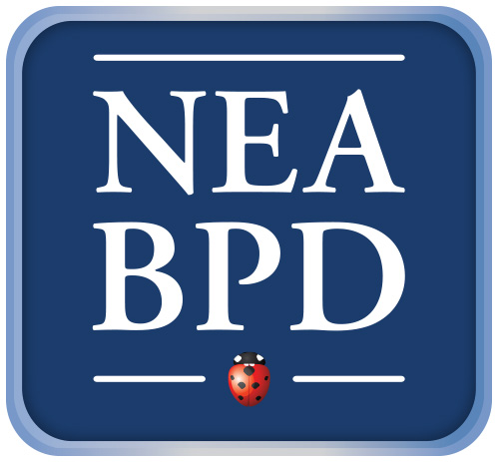

**WINTER: SUNDAY CALL-IN SERIES 2015 8pm to 9pm EST**

Thank you to our presenters who give freely of their time and expertise, and our planning committee: Andrea Gold, PhD, Elena Mayville, Ph.D. & Seth Axelrod, Ph.D.

**Registration for these free-of-charge sessions is at:** [**neabpdcalls@aol.com**](mailto:neabpdcalls@aol.com)

February 15th Charlie Swenson, MD and Kelly Koerner, Ph.D. Skills as the Core of DBT: Commentaries on the New Skills Manual

February 22nd Anthony Ruocco, Ph.D. Cognitive Functioning and Functional Abilities in BPD

March 1st Edward Selby, Ph.D. Emotional Cascades and Understanding the Chaos &Complexity of BPD

March 22nd Katherine L. Dixon-Gordon, Ph.D. The Interplay of Emotional and Interpersonal Processes in BPD

March 29th Diana Diamond, Ph.D. Transference Focused Psychotherapy for Severe Narcissistic Personality Disorders: Recent Developments in Research &Treatment

April 12th Kenneth Silk, MD Ask the Doctor: Medication and More

April 19th Marina Bornovalova, Ph.D. Quantitative Genetic Studies

 **Thank you to our sponsors**  

[***www.borderlinepersonaltydisorder.com***](http://www.borderlinpersonaltydisorder.com) ***neabpdcalls@aol.com***